**Login Page Report**

Master of Computer Application – General

Semester – III

**Sub: Web Technologies**

**Topic: Login Page of Web Page**  
By  
**Name:** SANDRA B  
**Reg no.:** 24110222500001

**Department of Computer Application  
Alliance University  
Chandapura - Anekal Main Road, Anekal  
Bengaluru - 562 106**

**August 2025**

|  |  |  |
| --- | --- | --- |
| **Sno.** | **INDEX** | **Page No.** |
| 1. | Introduction | 2 |
| 2. | Objective | 2 |
| 3. | Tools and Technologies Used | 3 |
| 4. | Code Explanation | 3 |
| 5. | Features of the Login Page | 4 |
| 6. | Output | 4 |
| 7. | Conclusion | 5 |

**Report on Login Page of Web Technologies**

**1. Introduction**

A **Login Page** is one of the most critical components of modern web technologies. It acts as the **first layer of security**, ensuring that only authorized users are granted access to confidential information, applications, or organizational resources. In today’s digital environment, almost every system—ranging from social networking platforms, e-commerce sites, educational portals, banking systems, and corporate dashboards—requires a secure and user-friendly login interface.

The main purpose of a login page is to **authenticate users** by collecting their credentials such as user ID, email, or password and verifying them against stored records. This not only helps in protecting sensitive data but also assists in **personalizing the user experience** by identifying the individual who is logged in.

In this project, a simple yet effective login page was designed and implemented using **HTML, CSS, and JavaScript**:

* **HTML** was used to build the **basic structure** of the form, including input fields such as Employee ID, Employee Name, Email, Password, and a Feedback section.
* **CSS** was applied to improve the **visual design** of the page, making it more attractive and user-friendly through layout adjustments, colors, margins, padding, and hover effects.
* **JavaScript** provided a layer of **interactivity** by implementing an alert message that confirms successful login when the user clicks the “Sign In” button.

The login page developed in this project not only collects the necessary employee information but also includes a **feedback section**, which is an additional feature to enhance communication between the user and the organization. Furthermore, the interface design emphasizes **simplicity, readability, and usability**, ensuring that even a first-time user can easily understand and interact with the form.

Overall, this project demonstrates the **importance of combining front-end web technologies** to design a professional login interface. While the current version does not include backend authentication or database integration, it establishes a strong foundation upon which more advanced login systems can be built in the future.

**2. Objective**

The main objectives of developing this login page were:

* To create a structured and responsive form for employee login.
* To apply CSS styling for a professional and modern look.
* To implement JavaScript functionality for basic interaction (alert on login).
* To redirect users to an external website after a successful login attempt.

**3. Tools and Technologies Used**

* **HTML** – for creating the structure of the login form.
* **CSS** – for designing and styling the webpage (colors, borders, buttons, alignment).
* **JavaScript** – for adding interactivity (alert message on successful login).
* **Web Browser** – to test and run the project.

**4. Code Explanation**

* **HTML Structure**
  + <head>: Sets page title (**Login Page**) and favicon.
  + <body>: Contains a **div box** with the login form.
  + **Form fields included**:
    - Employee ID → <input type="number">
    - Employee Name → <input type="text">
    - Employee Email → <input type="email">
    - Password → <input type="password">
    - Feedback → <textarea>
  + **Button**: A "Sign In" button which links to Alliance University website and calls a JavaScript function.
* **CSS Styling**
  + **Background color**: light cream for the page.
  + **Form box**: Centered, with borders, rounded corners, and shadow.
  + **Inputs & Button**: Rounded corners, shadow, hover effects (color change).
  + **Labels & Inputs**: Adjusted spacing using padding and margin.
* **JavaScript**
  + Function Click() shows an alert box:
  + **alert("Login Successfully!");**
  + This runs when the Sign In button is clicked.
* CSS properties such as **box-shadow, border-radius, hover effects, and alignment** make the form attractive.
* A **Sign In button** is provided, styled with hover effects. On clicking, a JavaScript function is executed that displays an alert message **"Login Successfully!"**, and the user is redirected to the **Alliance University website**.

**5. Features of the Login Page**

* **User-Friendly Design**: Simple and easy-to-use form layout.
* **Interactive Elements**: Hover effects on input fields and buttons.
* **Feedback Section**: Allows users to provide additional comments.
* **JavaScript Alert**: Provides instant feedback upon clicking Sign In.
* **Navigation**: Redirects the user to an external webpage after login.

**6. Output**

The implementation of the Login Page using HTML, CSS, and JavaScript results in a **visually appealing and functional interface**. The output demonstrates how the designed form collects user input, provides immediate feedback through an alert message, and then redirects the user to the specified website. The following describes the output in detail:

1. **Login page:**

A professionally styled form where employees can enter their ID, name, email, password, and feedback.

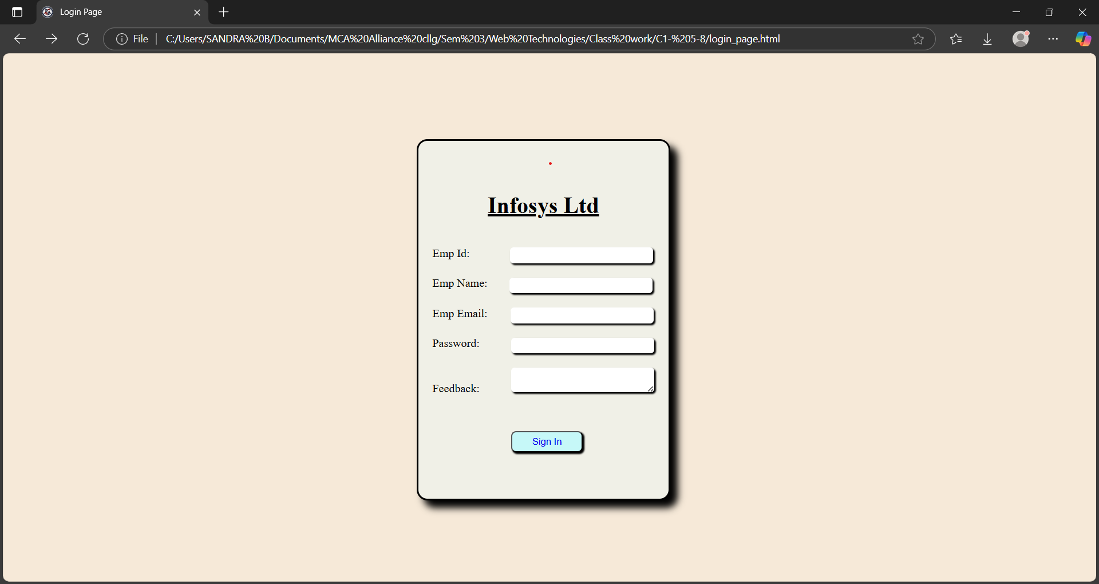

1. **Pop-up message page:**

An alert message appears confirming *“Login Successfully!”*.This alert helps in notifying the user that their input has been accepted before moving on to the next step.

1. **Click to next page:**

After the alert, the system automatically redirects the user to the Alliance University website, simulating a real login system’s navigation process.

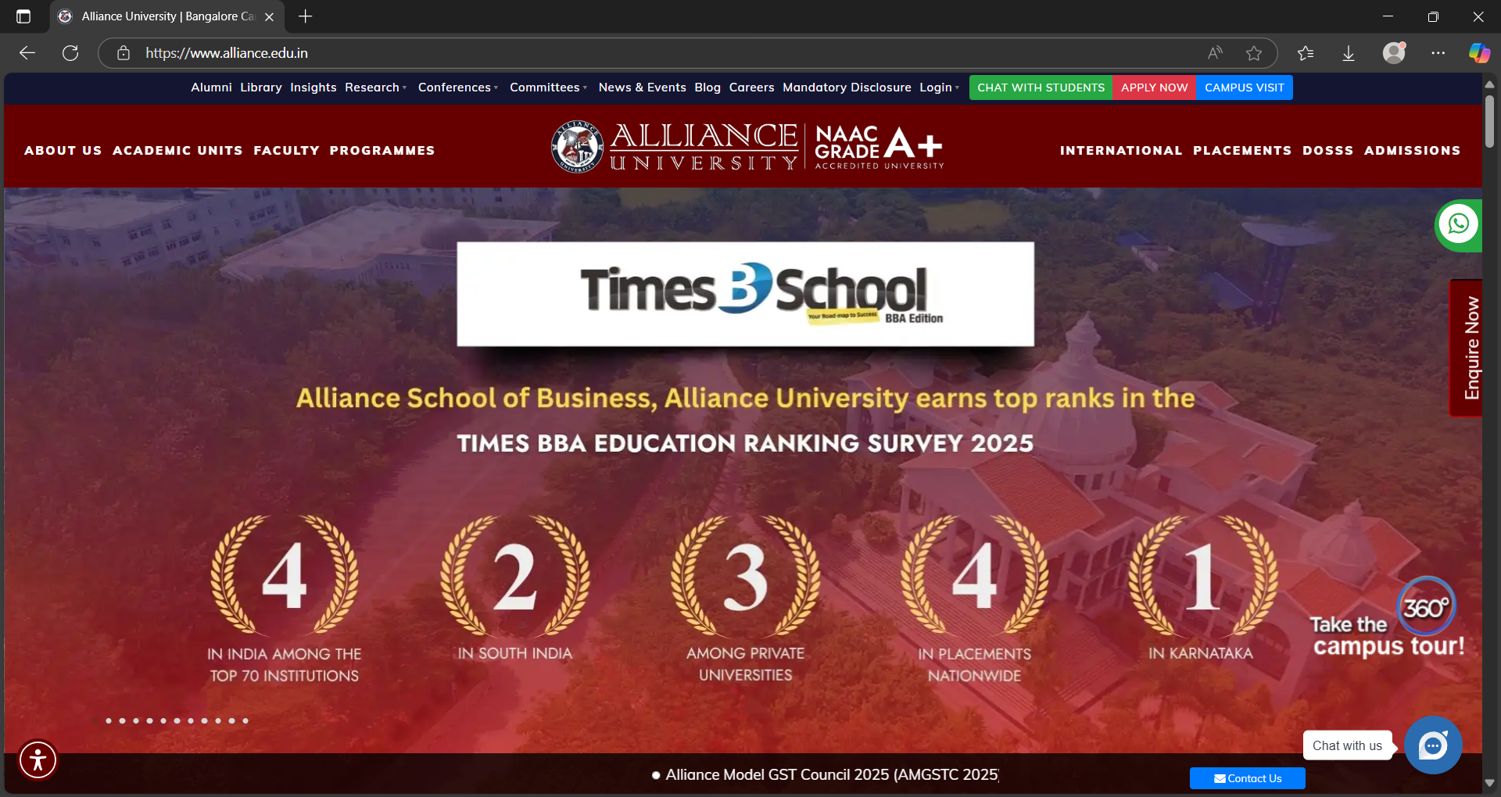

**7. Conclusion**

The login page project demonstrates the integration of **HTML, CSS, and JavaScript** to build a functional and visually appealing web page. It serves as a foundation for creating more advanced authentication systems with backend integration and database connectivity. This project not only enhances user interface design skills but also provides a basic understanding of web interactivity.